York College
The City University of New York
School of Health Sciences & Professional Programs Department of Health & Human Performance

HE 314 Nutrition and Health

Homework #1. Calculating Calories and Reading Food Labels

The purposes of homework #1 are as follows:

- How to calculate calories from grams carbohydrates, fats, and protein in a food?
- How to calculate total calories and to identify correct reporting of calories in food based on the Food Drug Administration Regulations?
- How to calculate the percentages of calories in food on a 2000 kcal caloric intake recommendation scale? Explain what Daily Value Percentage (DV%) represents? DV% for energy requirements or DV% for nutrient requirements?
- How to read, to interpret, and to explain what is on a food label in your own words (this means you have to proofread your written work)?
- Write a reflection on detailing.

Grading Criteria.
Weekly Homework Assignment Grading Rubric
Students completed all components of the task accurately and clearly. Substantive responses posted.
Student completed some of the task correctly but did not communicate his or her ideas clearly and/or did not post a substantive response.
Student’s post was irrelevant, unclear, unedited or student did not respond with anything of value. Student missed the submission date.
Student Reflection
Reflection entry is thoughtful, carefully written, and demonstrates self-reflection with regard to the topic.
Reflection entry is thoughtful, carefully written, and generally demonstrates self- reflection with regard to the topic.
Reflection entry shows lapses in care and depth of understanding the task at hand. Reflection entry is not thoughtfully written and does not suggest that the subject has been taken seriously.
Grade
9 to 10
3 to 8

0 to 2

Grade
5

4 to 3

2 to 1
0

Directions: Read and answer the following questions in detail.

Question #1. Calculating/Converting grams (g) to calories (kcal). Include all appropriate units and details.) [See example]

According to the weight (in grams[g]) of a biscuit that contains 10 g of fat, 40 g of carbohydrate, and 8 g of protein:

- How many calories (kcal) are from fat? Show calculation.
1g=9kcal
=10*9
=90kcal
- How many calories (kcal) are from carbohydrates? Show calculation.
1g=4kcal
=40*4
=160kcal
- How many calories (kcal) are from protein? Show calculation.
1g=4kcal
=8*4
=32kcal
- How many total calories (kcal) from one serving of biscuit? (Reporting of total calories must be in accord with FDA regulation)
=32+160=90
=282kcal
- The biscuit was so delicious, and Ross end up eating 2 servings of biscuit. How many total calories (kcal) overall? (Reporting values total calories must be in accord with FDA regulation)

=282*2

=464kcal

Question #2. Calculating calories from a food label (include all appropriate units and details).
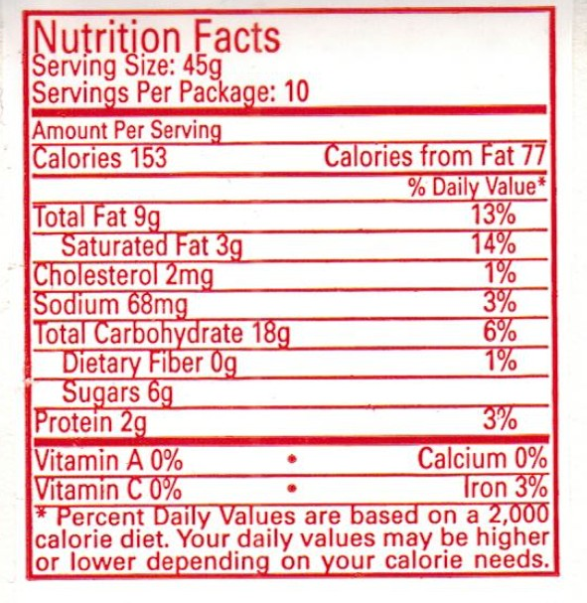


Here is a nutritional facts label from a local Italian box of cookies. Answer the following questions below.


- How many calories (kcal) are from fat in a serving? Show calculation.
1g=9kcal
=9*0
=18kcal

- How many calories (kcal) are from carbohydrates in a serving? Show calculation.
1g=4kcal
=18*4
=72kcal

- How many calories (kcal) are from protein in a serving? Show calculation.
1g=4kcal
=2*4
=8kcal
- How many total calories (kcal) from one serving of Italian cookie? Briefly explain why you chose your final answer (Reporting of total calories must be in accord with FDA regulations).
=8+72+18
=98kcal

- The cookies were so delicious, and Don ended up eating 5 servings of Italian cookies. ‘

  - How many total calories (kcal) did Don end up consuming?
=98*5
=490kcal
  - Based on the total servings that Don ended up consuming, what is the % Daily Value of Fats? And explain what it means using the facts on the label?

=18/490*100

=3.67%

Question 3. How to read, to interpret, and to explain what is on a food label in your own words (this means that you have to proofread your written work).

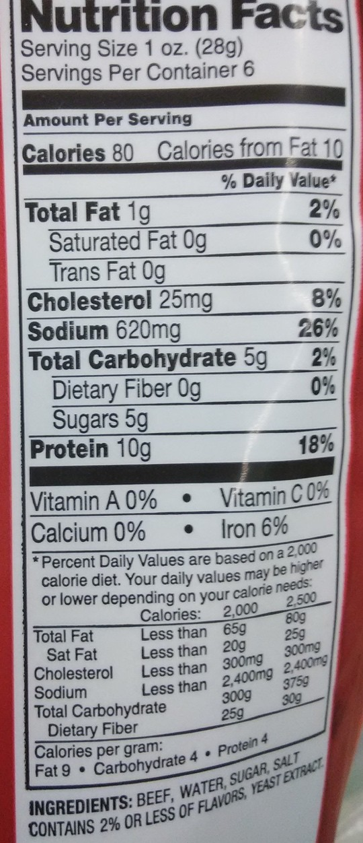
The product on this label is a commercialized beef jerky from a retail store.

Your role is the following:
    - Read the food label.
    - Explain the major components of a food label.
      - Discuss Serving Information.
The servings of this product is based on a single serving and includes; total fat at 1g, total carbohydrate at 5g and 10g of proteins with 65 of Iron.
      - Discuss Calories of this product.
The calories of this product includes 9kcal from fats, 20kcal from carbohydrates and 40kcal from proteins summing up to 69kcal per serving.
      - Explain what % Daily Value means for all nutrients. (Specify DV% for energy requirements or DV% for nutrient requirements?)
Percent Daily Value (DV) on the Nutrition Facts label is a guide to the nutrients in one serving of food. It provides 2% of fat per serving, 2% of carbohydrates per serving, and 18% of proteins per serving. For iron, it provides 65 per serving.
      - Explain why some nutrients do not have % Daily Value.
The nutrients that do not have the % daily value are not present in this particular product’s serving.
      - Discuss the expected quantity of each ingredient listed.
The quantities of ingredients listed provides the amount of each ingredient used while making the product such as beef, water, sugar, salt, yeast extract and 2% or less of flavors.

    - If a person consumes the entire product, what, then, would be the Daily Value changes? Second, discuss why the increase in DV% matters for each nutrient in terms of the 2000 caloric recommended value?
DV s are based on a 2,000-calorie diet for healthy adults. Thus if a person consumes the whole product the DV changes depending on each serving. This is because every single serving provides the DV and having more than one serving increases the DV by 2.
** You may use chart to show changes in DV% for each nutrient and it is expected that student will explain the chart in the student’s own words.

Student Reflection.

Now that you have completed the activities in Module #2, in concise, well-planned sentences, answer the questions below:

- In your own words, list at least 3 of the most significant (central, useful, meaningful, or surprising) information that you have learned during this module.
The most significant things learnt in this module is the total calories consumed from fats, carbohydrates, and proteins. Again I also learnt of the Daily Value percentage that a single serving provides.

- What question (s) remain most in your mind?
The question in my mind is whether the manufacturers always provide the right information in their products.

- Is there anything that you did not understand?
No .

